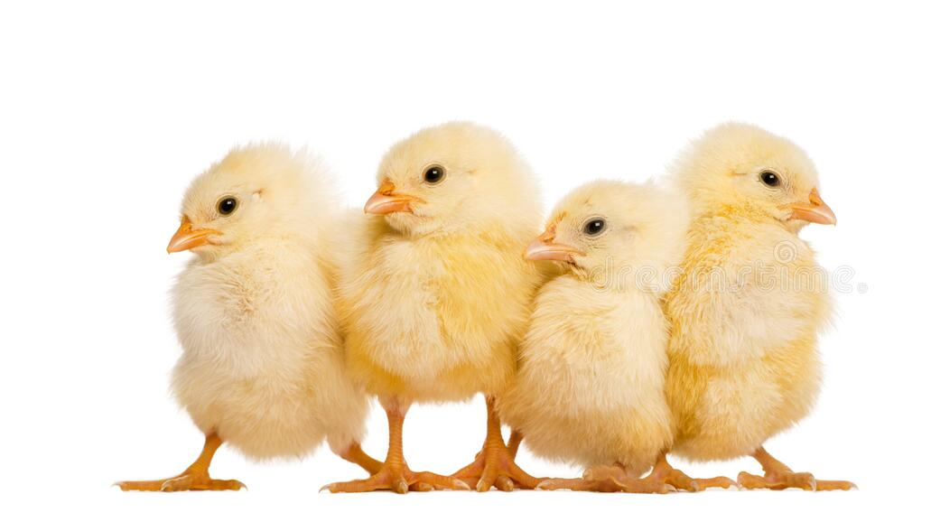
2026 Fentress County 4-H Chick Chain Project
The 4-H Chick Chain Project allows 4th – 12th grade members the opportunity to raise chickens. 4-H’ers will be given 20 baby chicks to raise! The baby chicks that you receive will be pullets. The Fentress County 4-H Chick Chain Fund will pay for the cost of the chicks. The project will end with the Poultry Show & Sale. Each 4-H member will be responsible for exhibiting 6 of his/her pullets, competing for prize money. At the end of the show, the pullets will be sold to finance the project. If, for any reason, you cannot bring the 6 pullets to the show, you must pay the average selling price of the 6 pullets.

Chick Chain Project Timeline
February 6th – Applications Due to the 4-H Office
February 12th – Chick Chain Workshop
March – Chick Arrival & Pick Up
August – Chick Chain Show & Sale
For more information about the Chick Chain Project, please contact:
Jenna Beaty, Extension Agent
931-879-9117
jenbeat@utk.edu
2026 Fentress County 4-H Chick Chain Project
- 4-H students in grades 4-12 can apply for the 4-H Chick Chain Project through the UT Extension-Fentress County Office. The application must be submitted by February 6th. The chicks should arrive in early March.
- Members must have the necessary facilities, equipment, and supplies to complete the project. Support or assistance from a parent or guardian is required.
- 4-H members chosen to receive the chicks must attend the 4-H Chick Chain Project educational meeting on February 12th at 5:30 p.m. If a member cannot participate in this meeting due to circumstances beyond their control they must contact Ms. Jenna at the office at 931-879-9117 to take a class to learn about the care and management of poultry.
- Each 4-H’er participating in the project will be notified of the exact arrival date for the chicks. Members are to come and pick up their chicks on that date at the 4-H office.
- The 4-H member will take the chicks home and raise them until they are mature and laying eggs.
- An invitation to the 4-H Chick Chain Show and Sale (August) will be sent to each participating 4-H’er who will bring six (6) chickens to the show and sale. The sale will follow the conclusion of the show. The chickens will then be sold to finance the project.
- Each 4-H’er participating in the 4-H Chick Chain Project must complete and submit a 4-H Chick Chain Journal, which documents their project work (expenses, goals, what was learned, what they would do differently next time, etc.).
- No other chicks can be shown or sold. It must be the chicks that you received from the 4-H Chick Chain Project.

Programs in agriculture and natural resources, 4-H youth development, family and consumer sciences, and resource development.
University of Tennessee Institute of Agriculture, U.S. Department of Agriculture, and county governments cooperating.
UT Extension provides equal opportunities in programs and employment.

4-H Chick Chain Application
Name: ______________________________________________ Phone: ___________________
Email: ______________________________________________
Address: ______________________________________________________________________
City: ____________________________ Zip: ___________________
School: _________________________________ Grade: ________ Teacher: ________________
___ Yes, I agree to enter the Chick Chain Project, and if chosen, I will care for & raise 20 baby chicks to the best of my ability, and return six (6) in the fall to help finance the project. If, for any reason, I cannot bring six (6) pullets to the show, I will pay the average selling price of 6 pullets. I understand that the money from the sale goes to UT Extension – Fentress County to fund the project.
Signature of 4-H Member: _____________________________________
Signature of Parent or Guardian: ________________________________

Please write a brief narrative explaining why you should receive chicks through the 4-H Chick Chain. (Use the space below to write your narrative)

Return this form by February 6, 2025:
UT Extension – Fentress County
3553 S York Hwy
Jamestown, TN 38556

